MANUAL 8 – LABTASKS

NAME: Rameen Fatima

CLASS: ME-15C

CMS:453962

DATE OF SUBMISSION:1/12/2023

**LABTASK 1:**

**CODE:**

#include<iostream>

using namespace std;

int main(){

cout << "Enter the total number of elements: ";

int n;

cin>> n;

int a[n];

float avg,sum;

cout << "Enter the elements: ";

for (int i =1;i<=n;i++){

cin>>a[i];

}

for (int i=1;i<=n;i++){

sum = sum + a[i];

}

avg = sum/n;

cout << "The average is:"<<avg;

}

**OUTPUT:**

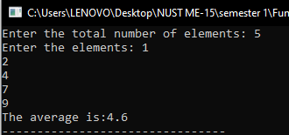

**LABTASK 2:**

**CODE:**

#include<iostream>

using namespace std;

//bubblesort

int main(){

int a[5]={4,7,2,1,9},temp;

cout << "Unsorted array"<< endl;

for (int i=0;i<=4;i++) {

cout << a[i]<<" , ";

}

for(int i=0;i<=4;i++){

for(int j=i+1;j<=4;j++){

if(a[i]>a[j]){

temp=a[i];

a[i]=a[j];

a[j]=temp;

}

}

}

cout <<endl<< "Sorted array"<< endl;

for(int i=0;i<=4;i++){

cout << a[i]<<",";

}

}

**OUTPUT:**

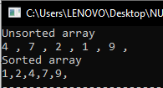

**LABTASK 3:**

**CODE:**

#include <iostream>

using namespace std;

int main(){

int a[5]={4,7,2,1,9},min;

cout << "Unsorted array"<< endl;

for (int i=0;i<=4;i++) {

cout << a[i]<<" , ";

}

for(int i=0;i<=5;i++){

min = a[i];

for(int j=i+1;j<=4;j++){

if(a[j]<a[i] && a[j]<min){

min=a[j];

a[j] = a[i];

a[i] = min;

}

}

}

cout <<endl<< "Sorted array"<< endl;

for (int i=0;i<=4;i++) {

cout << a[i]<<" , ";

}

}

**OUTPUT:**

